**Bountiful Foods**

**Mission Statement:** to provide fresh and healthy food options, including organic, made to order, fruit drinks and fruit bags, to the local population and to tourists visiting the coastal areas.

**Site Purpose:**

to manage orders and to show their mission statement through visual and written elements to their target audience.

**Target Audience:**

Carlsbad, California locals and tourists, as well as locals and tourists to coastal areas that their trucks cater to. Primarily younger clients who are out and about a lot. Those that want to eat healthy.

**Personas:**

* Abigail 25 local to Carlsbad who enjoys the outdoors and exploring new places. She is tired of eating fast food but needs something fast and easy to keep up with her lifestyle. She uses her laptop on her breaks at work but mostly uses her phone when she’s not at work
* Susan 37 tourist who is traveling along California’s coast with her 3 kids 15, 12, and 10 years old. She doesn’t want to eat fast food on her trip as it doesn’t make her feel the best. She has researched her trip online and finds most of her information off of websites from her phone on the go.
* Mathew is a marathon runner who just moved to California. He wants to eat food that will fuel his body in order to continue doing what he loves. Mathew uses his tablet to both track how far he runs and look for places to eat.

**Color Scheme:**

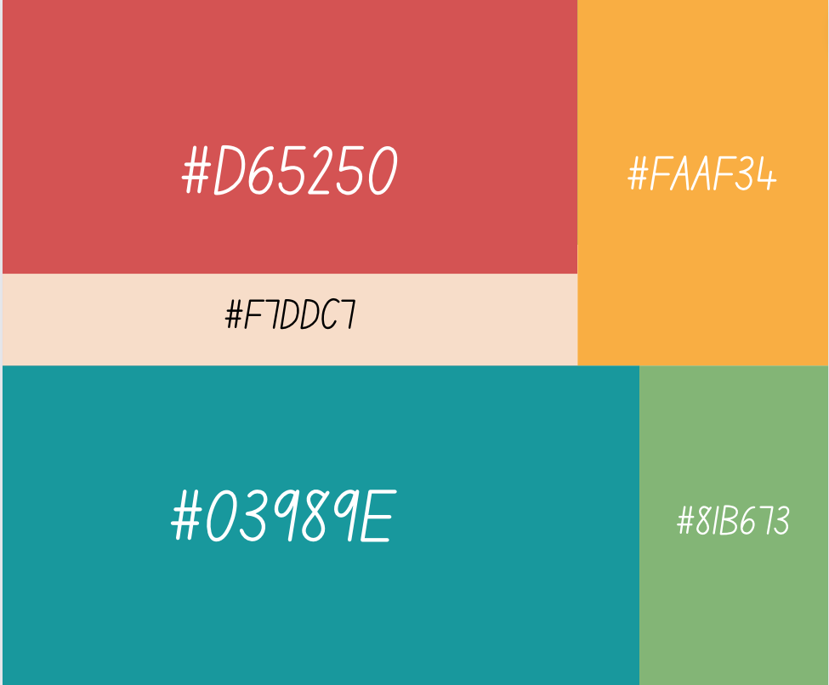

#D652050 will be the main color of the logo and images #F7DDC7 will be the background of the header. #03989E being a good contrasting color will be more prominent in the main body. All the photos will be following this color guide as well.

**Typography:**

<h1> Rubik Microbe

@import url('https://fonts.googleapis.com/css2?family=Rubik+Microbe&display=swap');

font-family: 'Rubik Microbe', cursive;

<h2> Montserrat bold

<h3> & <p> Montserrat

@import url('https://fonts.googleapis.com/css2?family=Montserrat&display=swap');

font-family: 'Montserrat', sans-serif;

**Wireframe Sketches:**

